Jake Mandel, Julian Dirado, Shreya Kumar

Term Project Mock-Up

**Persona 1:** Joe is a college student who can’t afford his school bookstore prices for textbooks. It is also too difficult to find a person selling the specific book he needs. After he started using BookPedia, he can find a variety of used books online. Now he can search for any textbook he needs, and purchase it at a competitive price. Joe likes that the app feels familiar to other marketplace applications, and he feels it is simple and easy to navigate. A question to survey Joe’s experience would be: “What are your favorite features of the app? What would you change?”

**Persona 2:** Michael is an alumni with a surplus of old textbooks. He wants to just get rid of the books, but would rather sell them. However, he can’t find anyone who needs each specific book. After he started using BookPedia, he can list all of his textbooks in one place, for many people to see. Now he can make a profit on his old books, instead of holding or donating them.

Michael likes that the app helps him reach more potential buyers, apposed to trying to sell locally. A question to survey Michael’s experience would be: “How would you compare BookPedia to other competing platforms, such as Ebay?

Cellphone View:

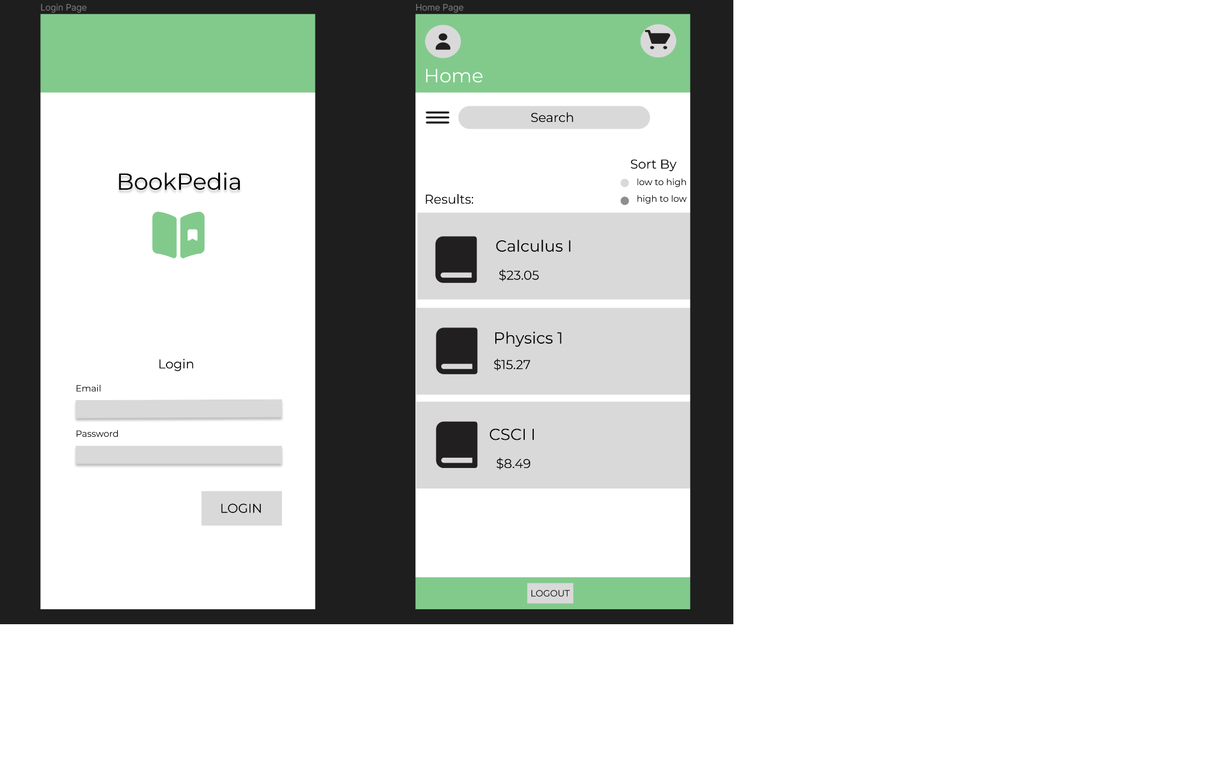Computer View Login Page:

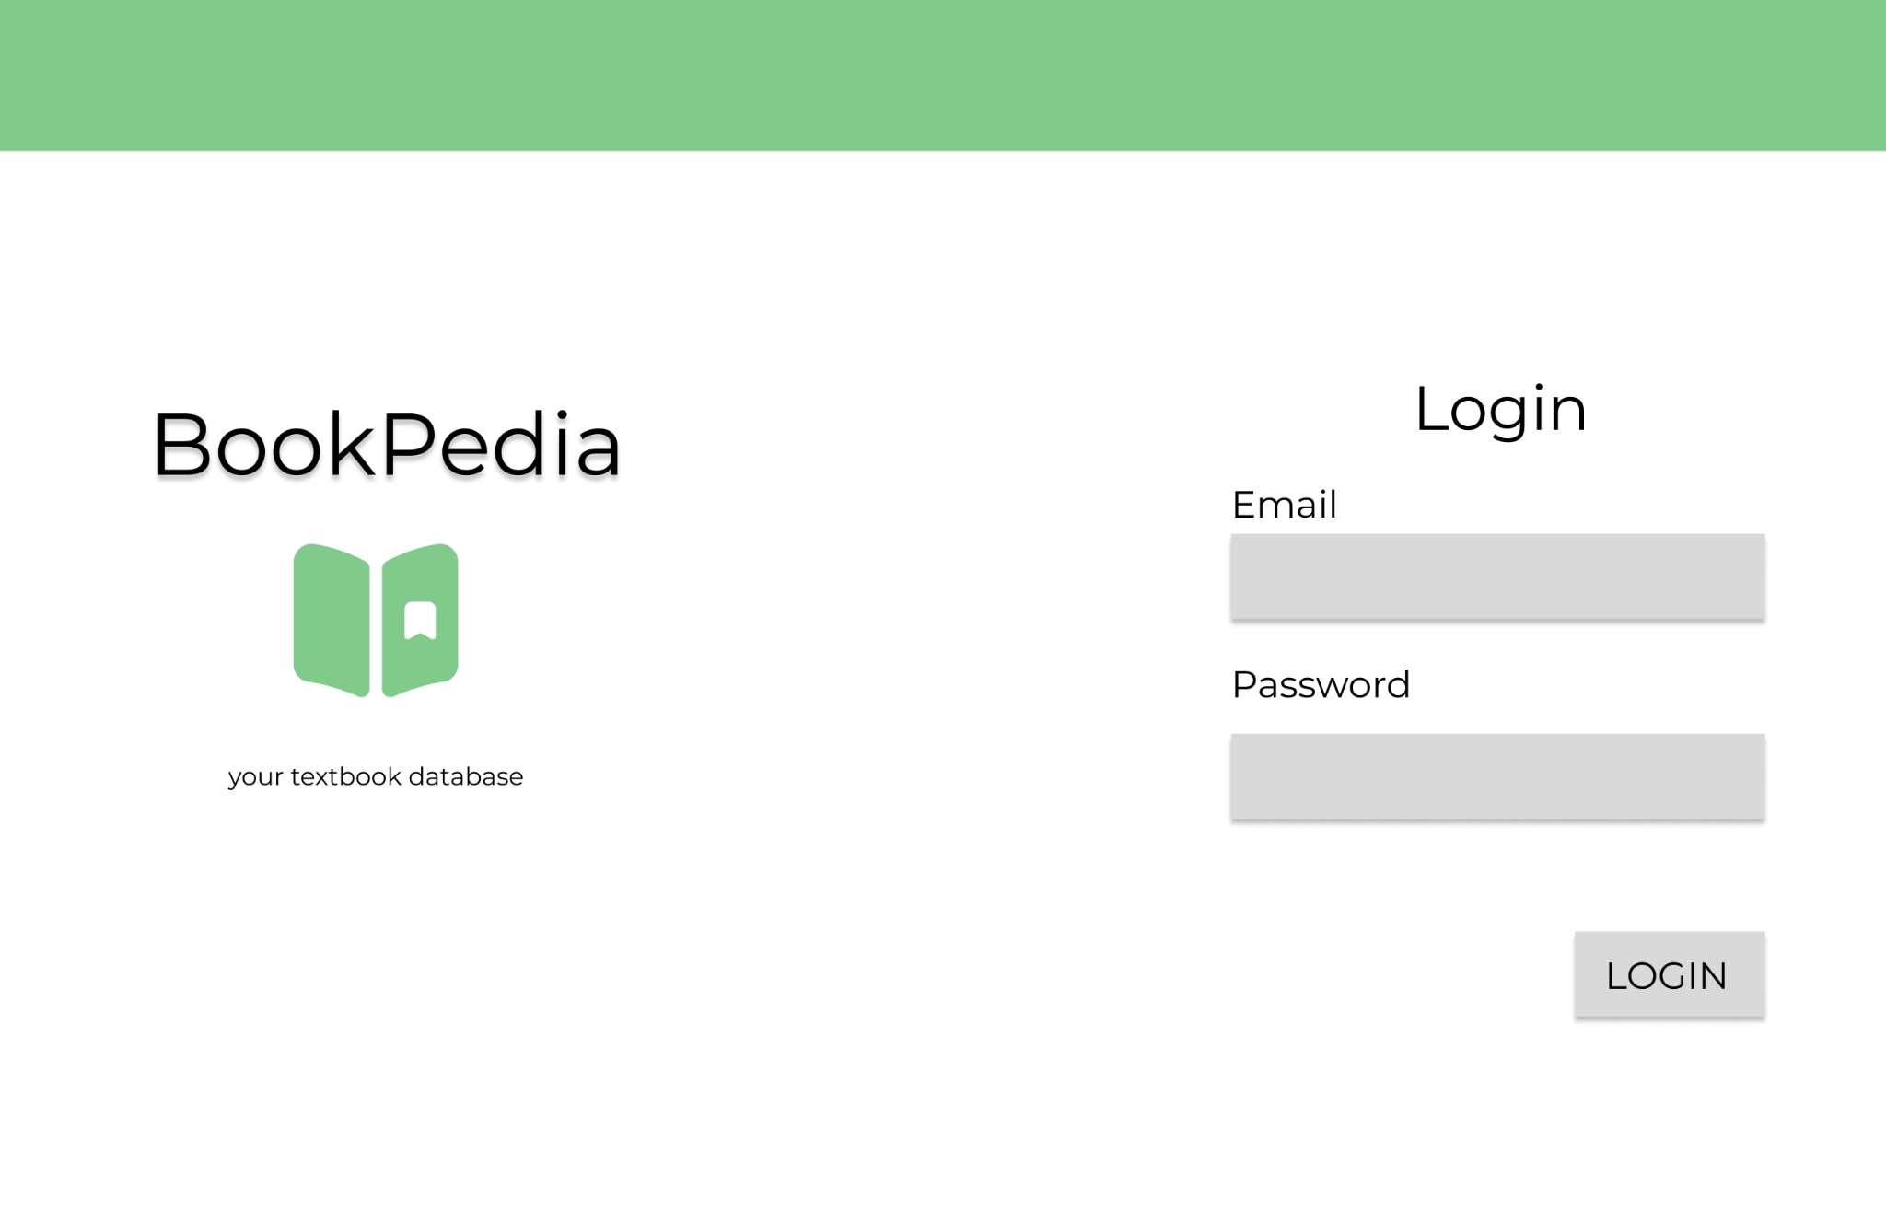

Home Page:

